- Log into your account at www.paypal.com
- Select “Send & Request” at the top of your screen
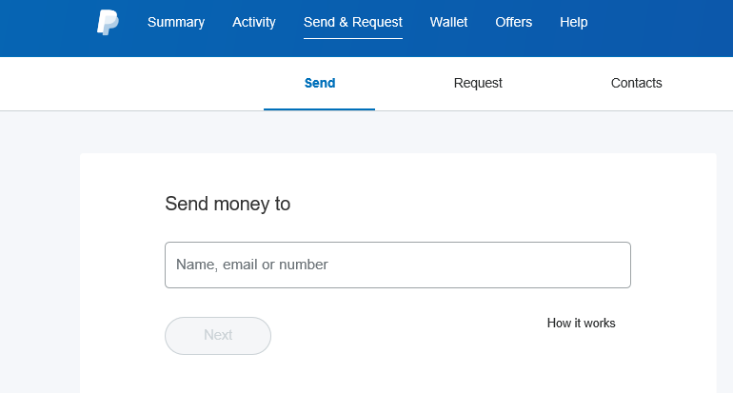
- In the “Send money to”, enter BayAreaDivers@gmail.com

- Type in the Amount to be paid…

- YOU MUST CHANGE THE “Paying for an item or service” (default) to “Sending to a friend”! Please do not leave the default or it will charge the club the service fee.

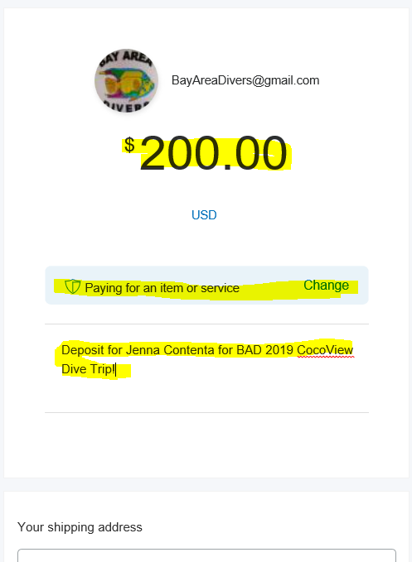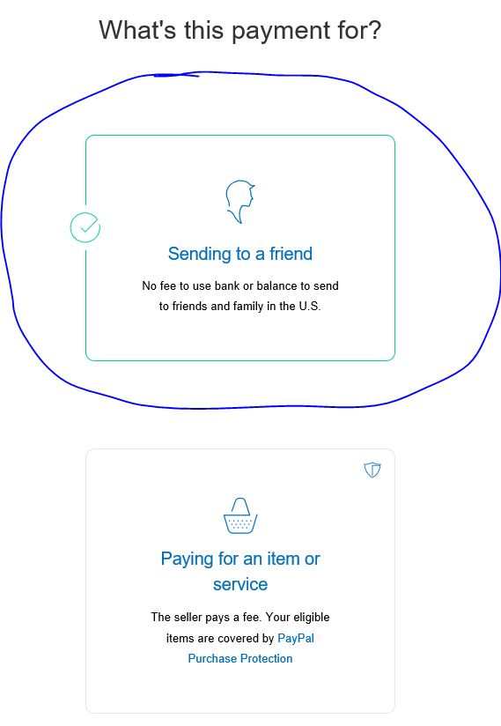
- Review your data is correct…
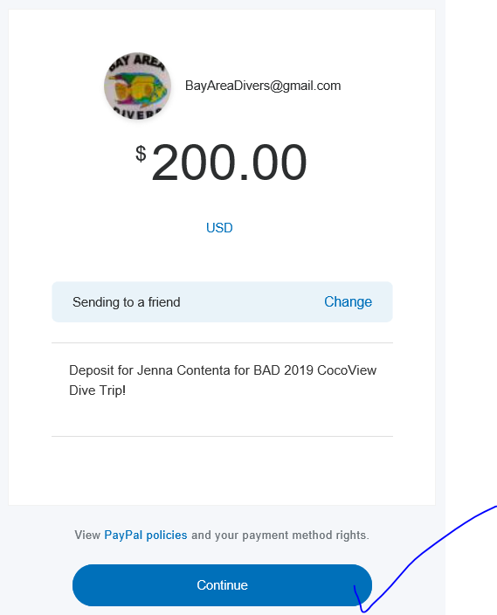
- Confirm your payment… by selecting “Send Payment Now”
Note: There will be a service fee to you depending on how your PayPal payments are setup.
There is no fee if bank drafted. See their PayPal policies for more information.

